To obtain a position that will enable me to use my strong organizational skills, award-winning educational background, and ability to work well with people. Seeking a challenging role in Java Full Stack Development where I can leverage my expertise in Programming Languages like C, C++, Java , HTML, JavaScript and Relational Databases like Oracle & MySQL to contribute to the growth and success of the organization.

# ----- EDUCATION -----

**Secondary School Certificate (SSC) - X Exam** Mar '17

## Abhinav Vidyalaya Highschool Katraj, Pune

• Achieved an **65%**, demonstrating a strong commitment to academic excellence and a solid foundation for future educational pursuits

**Higher Secondary Certificate (12th Grade) - Science Stream** Feb '19

## Pirangut Junior College Kondhwa, Pune

• *Navigated the challenges of college life with enthusiasm, and in hindsight, this journey has sharpened my focus on my future goals. Achieved a solid*

***62.15%****,* demonstrating a willingness to learn and adapt, setting the stage for my ongoing pursuit of academic and personal growth.

**B.Sc. (Computer Science)** Aug '21 - Apr '23



**SUMMARY**



+91

7499661910



G

rpansare2

002

@gmail.com



Pune, India, IN, 411037



L

inkedin.

com/Ganesh Pansare



Ganesh Pansare



Java Full Stack Developer



## Yashwantrao Mohite College of Arts, Science and Commerce (YMC-BVDU) Paud Road, Pune

* Computer Science degree *Focused on modern approaches to software systems development, computer architecture, and computer networks.*
* *Attained an impressive* ***8.43 CGPA****,* reflecting my dedication to excellence in a rigorous academic program.
* *My journey into the world of programming began during my college days, igniting a passion for coding that has continued to grow.*
* *Where I have learned C programming, Java, HTML, CSS, JavaScript, SQL, Some Basic Knowledge of Data and Computer Networking.*

# ----- Certificates -----

**Full Stack Java Developer Course** Jun '23 - Dec '23

## SEED Infotech Ltd Karve Road,Pune

I have acquired proficiency in developing full-stack web applications, encompassing both front-end and server-side components. My expertise extends to application deployment, debugging, and the maintenance of databases and servers. *I proudly achieved "* ***A Grade*** *".*

In this journey, I've charted a course through a diverse technological landscape, skillfully harnessing the following tools and languages to navigate the ever-evolving digital realm : -

* Basic Technology – C programming
* Databases – SQL and No SQL
* Front End Technology – HTML, CSS, Bootstrap, JavaScript
* Server Side Programming – Core Java, Java

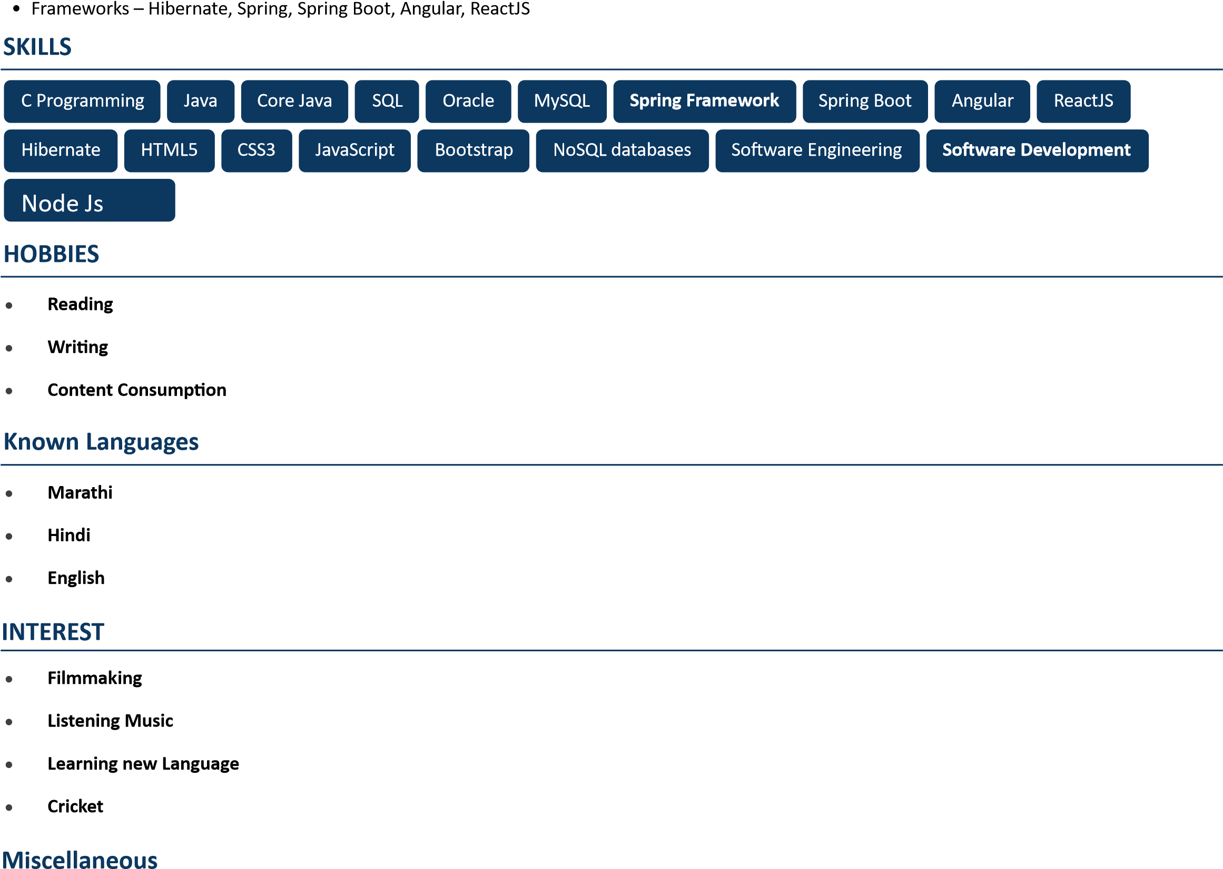

* **Got the scholarship by securing first rank in Pre-Secondary School Scholarship Examination .**

# PROJECTS

**Library Management System** Jan '23 - Mar '23

**Academic Project** B.Sc (Computer Science)

* This project was spearheaded by group of 3 students, including myself.
* One of the core functionalities of "News Network" is its real-time news display. When a user enters a keyword of interest, the application fetches and presents a stream of news articles related to that keyword on a user-friendly webpage.
* "News Network" harnesses a versatile technology stack, encompassing HTML, CSS, JavaScript, Bootstrap, Java Servlet, and JSP (JavaServer Pages). In addition, we seamlessly integrated a News API, enabling the application to retrieve and present a vast array of news articles available on the internet.

**Online Bookstore** Aug '23 - Oct '23

## Personal Project

* The "Online Medicine System" is a personal project that serves as an all-in-one platform to discover, explore, and shop for their medicines on affordable rates in the digital realm.
* My personal project, the 'Online Medicine System,' utilizes HTML, CSS, JavaScript, Bootstrap, Java Filters, JDBC, Java Servlets, and JSP. It also seamlessly integrates a secure payment gateway for hassle-free online transactions.